**ACKNOWLEDGEMENT**

I am happy to present this report on the internship program. This Program would not have been possible without the guidance, assistance, and suggestions of many individuals. I would like to express my deep sense of gratitude and indebtedness to each and everyone who has helped during my internship program.

I express my heartfelt gratitude and sincere thanks to **Dr. Mohan Babu G . N, Principal of BMSIT&M** for his constant encouragement and inspiration.

I sincerely convey my thanks to **Dr. Thippeswamy G, Head of the Department, Computer Science and Engineering, BMSIT&M** for her constant encouragement and support.

I gracefully thank my Internal Guide, **Mrs. Durga Bhavani A, Assistant Professor, Department of Computer Science and Engineering, BMSIT&M** for his/her guidance, support, and advice.

I heartily thank my External Guide, **Korhan Dulge, Senior IT Delivery Lead, Johnson Controls** for his/her constant support, encouragement, and advice.

Finally, I would like to thank my parents, friends, and all those who are involved in the successful completion of the internship program.

**Likith S**

**1BY18CS081**

**I**

**Internship Letter**



**II**

**ABSTRACT**

Johnson Controls International is an American Irish-domiciled multinational conglomerate headquartered in Cork, Ireland. The Company offers HVAC equipment, building automation, security, fire detection, batteries, and other related products, as well as building control systems, energy management, and integrated facility management services. As a part of my internship, I worked on migrating data from multiple legacy ERP systems to Oracle Fusion ERP System. I was part of the pilot run for the EMEA region with the focus being Belgium. The internship has enriched my knowledge about ERP Systems, IICS Tool, and Data Migration processes. Time Management, Communication Skills were also key takeaways while working as a team during the Internship period of 24 weeks.

**II**

**TABLE OF CONTENTS**

**1 ACKNOWLEDGEMENT I**

**2 INTERNSHIP CERTIFICATE II**

**3 ABSTRACT III**

**4 TABLE OF CONTENTS IV**

|  |  |
| --- | --- |
| 1. **JOHNSON CONTROLS** | **1** |
| 1.1 Vision | 1 |
| 1.2 Overview | 1 |
| 1. **ABOUT THE ERP DEPARTMENT** | **3** |
| 2.1 ERP Department | 3 |
| 2.2 Team Objective | 3 |
| 2.3 Team Operation | 4 |
| 2.4 Data Migration | 5 |

| 1. **TASKS PERFORMED** | **7** |
| --- | --- |
| 3.1 Domain Training | 7 |
| 3.2 About Data Migration using IICS | 9 |
| 3.3 Project Requirements | 10 |
| 3.4 System Design | 10 |
| 1. **OUTCOMES** | **11** |
| 4.1 Technical Outcomes | 11 |
| 4.2 Non-Technical Outcomes | 18 |

| 1. **CONCLUSION** | **19** |
| --- | --- |
| 1. **REFERENCES** | **20** |

**List of Figures**

**Figure Title Page No**

1.1 Company Vision 2

2.1 Approach Strategy 5

3.1 IICS Tool Interface 8

3.2 System Design 10

4.1 Comparison of ETL Tools 13

4.2 Oracle Fusion Architecture 14

4.3 Relationship between resources 17

**IV**

**Chapter 1**

**About the Company**

**1.1 Vision of the Company**

**The Power Behind Your Mission -** At Johnson Controls, they transform the environments where people live, work, learn and play. From optimizing building performance to improving safety and enhancing comfort, they drive the outcomes that matter most.

Dedicated to protecting the environment, they deliver our promise in industries such as healthcare, education, data centers, and manufacturing.

**1.2 Overview**

**Enhancing the Intelligence of Buildings -** Buildings have a purpose.

They are places for people to live or work. Facilities for learning or healing. Venues for entertainment and shopping. Sites for the specialized storage of tangible goods or mission-critical data. Your buildings have a huge variety of functions; they are central to your mission.

This is where Johnson Controls comes in, helping drive the outcomes that matter most. Through a full range of systems and digital solutions, they make your buildings smarter. A smarter building is safer, more comfortable, more efficient, and, ultimately, more sustainable. Most important, smarter buildings let you focus more intensely on your unique mission. Better for your people. Better for your bottom line. Better for the planet.

At Johnson Controls, they’ve been making buildings smarter since 1885, and our capabilities, depth of innovation experience, and global reach have been growing ever since. Today, they offer the world’s largest portfolio of building products, technologies, software, and services; they put that portfolio to work to transform the environments where people live, work, learn and play.

**History**

In 1885, long before anyone talks about carbon footprints or climate change, Warren Johnson launches a company to explore new ways to harness and conserve precious energy resources. In doing so, he also launches a tradition of customer-focused innovation—a tradition that has inspired thousands of employees for more than 130 years and that continues to drive the success of Johnson Controls. Even before he founds the firm now known as Johnson Controls, Warren Johnson is the quintessential inventor. His pneumatic tower clocks, electric storage batteries, wireless telegraph business, and steam-powered luxury cars and postal service trucks anticipate—and shape—the future.



Fig 1.1 Company Vision

**Chapter 2**

**About the Department**

**2.1 ERP - Data Migration Team**

The team is responsible for migrating data from multiple legacy ERP Systems to the Oracle Fusion ERP system. The project titled FOCUS consists of full-time resources assigned to work on the deliverables of the project. This includes technical specialists, data stewards, data analysts, Azure developers, etc. They are responsible for:

* + - Understanding the work to be completed.
    - Planning the assigned activities in more detail if needed.
    - Completing assigned work within the budget, timeline, and quality expectations.
    - Informing the project manager of issues, scope changes, risks, and quality concerns.
    - Proactively communicating status and managing expectations.

**2.2 Team Objective**

A critical objective of JCI Project OpCo(Belgium Pilot) is the removal of end-of-life technology and the transition to Oracle cloud as a single ERP solution for EMEA. This will involve the migration of data from the legacy ERP systems to the Oracle cloud. This involves analyzing the legacy data, mapping data from the legacy systems to the new systems, applying validation rules, transformation rules, deduplication of data for cleansing wherever required, and reconciling the converted data.

Data migration is the process of moving data from one location to another, one format to another, or one application to another. Generally, this is the result of introducing a new system or location for the data. The business driver is usually an application migration or consolidation in which legacy systems are replaced or augmented by new applications that will share the same dataset. These days, data migrations are often started as firms move from on-premises infrastructure and applications to cloud-based storage and applications to optimize or transform their company.

The objectives of Data Migration are:

* **Ensuring data is completely and accurately migrated** from the source platform to the target platform following company policies and relevant compliance standards. This means there are no records in the target environment that are missing, incomplete, or failed some form of validation.
* **Get the target system running as quickly as possible** with a minimal amount of downtime and disruption to business operations.
* **Minimize costs of migration** in terms of technology and manpower requirements.

**2.3 Team Operation**

The team consists of internal resources from Johnson controls as well as external resources from Infosys who were supporting this project. Microsoft Teams is used for communication and Microsoft Sharepoint is used to collaborate and coordinate work. Within one window, users can call upon a variety of key Office 365 apps and tools to help them work more effectively, such as

* Calendars and meetings (Outlook)
* Create, share, edit and find content (SharePoint, OneDrive, and OneNote)
* Call and meet team members (Skype)
* Chat and instant messaging (Skype)

The benefits of using Microsoft Teams are

* One centralized hub and Office 365 integration
* Customize Teams through APIs and bot frameworks
* Enterprise security & compliance

**2.3.1 Planning**

In addition to organizing itself, one of the first steps in the data migration process is to obtain a thorough understanding of the task at hand. We need to understand the project objectives, the specifications/customer requirements, mapping targets, tools cost, and schedule. This information should be provided to the team(s) by the program manager or management team, and the team(s) must thoroughly review these requirements.

**2.3.2 Team Building**

As teams are formed, there is a need to recognize the interpersonal dynamics that exist to make the team process effective. People assigned to the development team will represent a variety of personalities and styles. The different perspectives that the people bring to the team can enhance its vitality and creativity.

**2.4 Data Migration Phases**

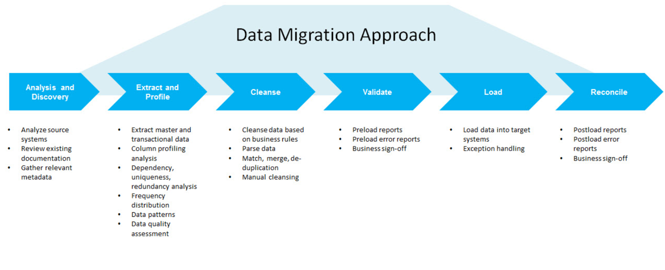

Fig 2.1 Approach Strategy

**2.4.1 Analysis and Discovery**

This phase in the data migration process involves analyzing source systems, reviewing existing documentation, and gathering relevant metadata. All this is achieved through interacting with the business users and data stewards and gathering relevant information. It also involves interacting with the Oracle COE team to gather requirements.

**2.4.2 Extract and Profile**

Data is extracted from source systems by first setting up connections to the database in the tool. Master and Transactional data(Customer Master, Item Master, etc.) is extracted at this phase. After extraction, profiling tasks are performed on the data in the form of column profiling analysis which include dependency, uniqueness, and redundancy analysis. The results are analyzed to identify frequency distribution, data patterns, and also data quality assessment.

**2.4.3 Cleanse**

After the analysis of results, based on the input from the business team, data cleansing is performed. It involves parsing, matching, merging, and deduplication of data. If necessary, manual cleansing is also performed.

**2.4.4 Validate**

After cleansing, preload reports and preload error reports are generated using the rules given by the Oracle COE team. The same is shared with the business team for their approval.

**2.4.5 Load**

Once the business team signs off the reports, data is loaded into target systems(Oracle Fusion) and during loading, exception handling is also performed to prevent the crashing of the process.

**2.4.5 Reconcile**

In this phase, postload reports and postload error reports are generated to present the findings to the business team. After their approval, the process is considered successful.

**Chapter 3**

**Task Performed/ Internship Activities**

**3.1 Domain Training**

Informatica IICS tool was used to perform the data migration. Informatica Intelligent Cloud Services (IICS) is a cloud-based data integration platform that provides a variety of features such as business data integration, application integration, and API management between cloud and local applications.

It is a next-generation iPaaS (Integration Platform as a Service) solution offered by Informatica. Based on a microservices architecture and a modern user interface, the IICS platform is built for the future to provide complete end-to-end data management in a uniform, non-siloed approach. IICS unifies existing Informatica cloud service offerings and expands into a full suite of cloud data management services over time. IICS will be comprised of four clouds: Integration Cloud, Data Quality & Governance Cloud, Master Data Management Cloud, and Data Security Cloud, powered by a common core platform and the Informatica CLAIRE metadata intelligence engine.

IICS provides a complete, modular, end-to-end solution for managing data in hybrid cloud and multi-cloud environments. Engineered to scale and deliver data at the speed of business, IICS focuses on data integration rather than infrastructure management and maintenance.

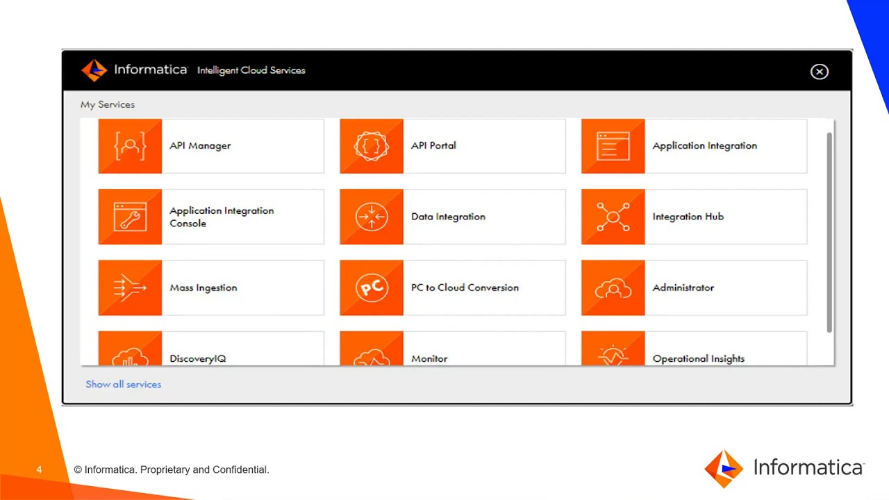

Fig 3.1 IICS Tool Interface

CDI-Elastic with CLAIRE (Informatica’s AI engine) opens a new paradigm for organizations, enabling them to reach higher levels of productivity and scale. CDI-Elastic provides a serverless experience, allowing a data engineering team to focus on data flow application logic and data integration. Using the familiar Informatica Cloud Data Integration interface, you can now develop and run your mappings’ reading or writing into Microsoft Azure Data Lake Storage (ADLS) Gen2 or Azure Synapse Analytics (formerly SQL Data Warehouse) in a serverless fashion. CDI-Elastic uses Spark for large-scale data processing and Azure Kubernetes Service as the orchestrator.

With CDI-Elastic, there’s no need to reserve resources or long-running VMs for data processing. You pay only for the time it takes for your mappings or tasks to be executed. In addition, you can automatically scale your Informatica mappings up and down. Built-in automated high availability and fault tolerance means you don’t need to architect for these services.

**3.2 About Data Migration using IICS**

Data Extraction from Baan into IICS can be done in two ways – direct query extract OR excel extract from Baan, then upload of the same. For practical purposes, Direct Query Extract is the best functionality since it reduces the risk of manual handling of data. Only Company 160 items are required to be extracted and converted into a Fusion system.

Validation rules are conversion specific and need to be updated accordingly. The validation rules are combined in a rule set. All rules except ‘Custom Validation Rule’ are universal, which means they can be used for all tables if the column name is the same. Once the ruleset is created and executed, a combination of validation reports is generated by the tool itself for each rule of the ruleset, and one cumulative report describes the records which failed/passed any/all rule(s).

The validation reports generated by the tool are communicated to the business team. Based on the rule status, the decision can be taken by the client to change validation rules or rectify the data in the tool.

Data transformation in IICS is done through an ETL ‘Transform and Load task’ wherein a plethora of transformation rules can be configured, such as mathematical functions, lookups, value-mappings, etc

De-duplication involves fuzzy logic comparison of items based on item number and description. The tool matches each record in the item table and creates a match percentage according to the mathematical formulae of the chosen fuzzy method.

Approval/Rejection of records by business users happens in the De-duplication Excel shared over JCI Sharepoint. Based on the approval/rejection of records by the client in the above process, records are exported from the tool in the fixed FBDI format of the Item Import template. After the generation of the FBDI files, the data is loaded into Oracle Fusion systems. Once Data is uploaded to the Oracle Fusion cloud, the reconciliation report is generated.

**3.3 Project Requirements**

#### **Software Requirements**

* Informatica Intelligent Cloud Service
* Azure Storage Containers
* Oracle Fusion Cloud
* Source Datastores

#### **Hardware Requirements**

* A standard computer with internet connection as the entire process is done on the cloud
* Azure Storage Explorer installed(optional)

**3.4 System Design**

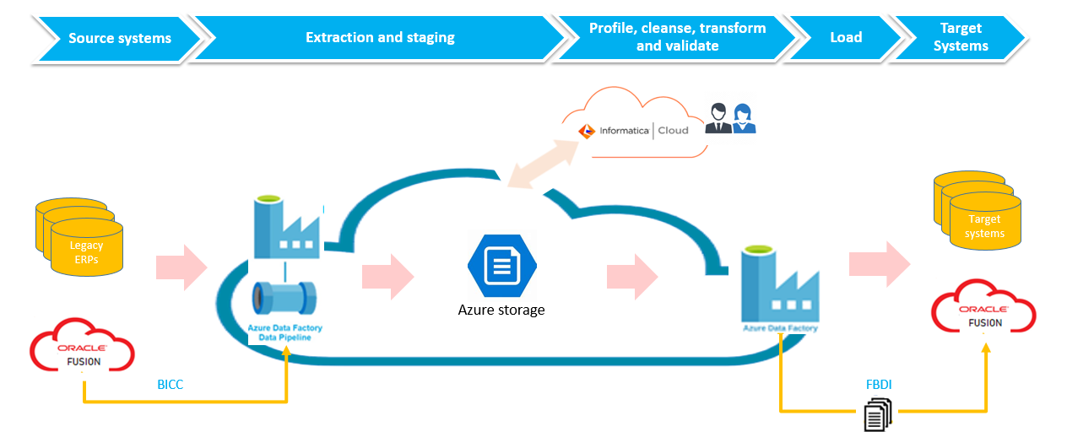

Fig 3.2 System Design

**Chapter 4**

**Specific Outcomes**

**4.1 Technical Outcomes**

During my internship program, I understood the importance of data and why it is important to store data safely. I learned about different ERP Systems primarily Oracle Fusion and why it is important to have a globally accepted ERP System in place.

I learned about different ETL tools available in the market and understood our use case for choosing IICS. I learned how to use the tool effectively. I also learned about Azure Data Factory and Azure Storage Containers.

**ERP Systems**

Enterprise resource planning (ERP) refers to a type of software that organizations use to manage day-to-day business activities such as accounting, procurement, project management, risk management and compliance, and supply chain operations. A complete ERP suite also includes enterprise performance management, software that helps plan, budget, predict, and report on an organization’s financial results.

ERP systems tie together a multitude of business processes and enable the flow of data between them. By collecting an organization’s shared transactional data from multiple sources, ERP systems eliminate data duplication and provide data integrity with a single source of truth. Today, ERP systems are critical for managing thousands of businesses of all sizes and in all industries. To these companies, ERP is as indispensable as the electricity that keeps the lights on.

Enterprise resource planning systems are complete, integrated platforms, either on-premises or in the cloud, managing all aspects of a production-based or distribution business. Furthermore, ERP systems support all aspects of financial management, human resources, supply chain management, and manufacturing with your core accounting function.

ERP systems will also provide transparency into your complete business process by tracking all aspects of production, logistics, and financials. These integrated systems act as a business's central hub for end-to-end workflow and data, allowing a variety of departments to access. ERP Systems and software support multiple functions across the enterprise, mid-sized, or small businesses, including customizations for your industry.

It’s impossible to ignore the impact of ERP in today’s business world. As enterprise data and processes are corralled into ERP systems, businesses can align separate departments and improve workflows, resulting in significant bottom-line savings. Examples of specific business benefits include:

* Improved business insight from real-time information generated by reports
* Lower operational costs through streamlined business processes and best practices
* Enhanced collaboration from users sharing data in contracts, requisitions, and purchase orders
* Improved efficiency through a common user experience across many business functions and well-defined business processes
* Consistent infrastructure from the back office to the front office, with all business activities having the same look and feel
* Higher user-adoption rates from a common user experience and design
* Reduced risk through improved data integrity and financial controls
* Lower management and operational costs through uniform and integrated systems

**Comparison of ETL Tools**

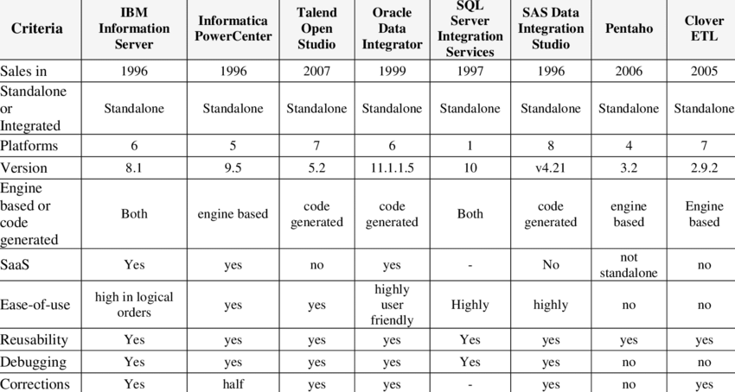

Fig 4.1 Comparison of ETL Tools

**Oracle Fusion**

Using the latest technology and incorporating the best practices gathered from Oracle's customers, Oracle Fusion Applications is a suite of 100% open standards-based business applications that provide a new standard for the way businesses innovate, work and adopt the technology. Delivered as a complete suite of modular, service-enabled enterprise applications, Oracle Fusion Applications works with Oracle's Applications Unlimited portfolio to evolve the business to a new level of performance. Whether it is one module, a product family, or the entire suite, Oracle provides businesses with their choice of all advancements pioneered by Oracle Fusion Applications, at a pace that matches individual business demands.

Oracle Fusion Applications can best be described as

* Built on an open standards-based platform
* Based on best practices business processes
* Deployed through a selection of options
* Built with security as a priority

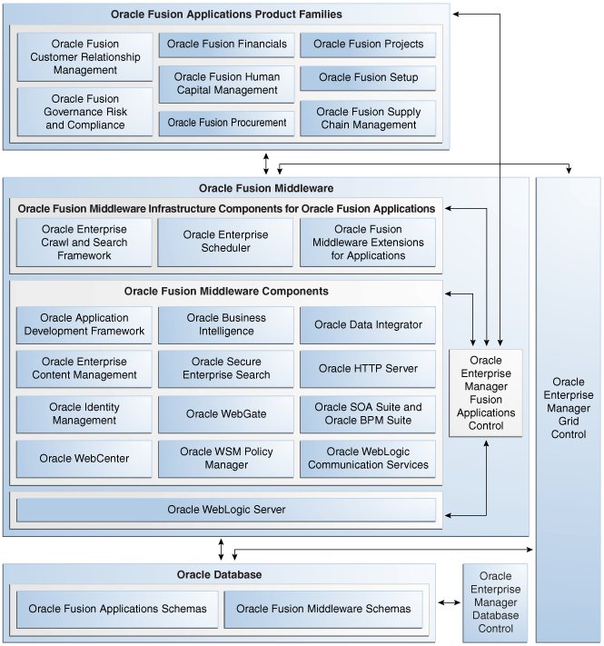

Fig 4.2 Oracle Fusion Architecture

**Azure Data Factory:** For example, imagine a gaming company that collects petabytes of game logs that are produced by games in the cloud. The company wants to analyze these logs to gain insights into customer preferences, demographics, and usage behavior. It also wants to identify up-sell and cross-sell opportunities, develop compelling new features, drive business growth, and provide a better experience to its customers.

To analyze these logs, the company needs to use reference data such as customer information, game information, and marketing campaign information that is in an on-premises data store. The company wants to utilize this data from the on-premises data store, combining it with additional log data that it has in a cloud data store.

To extract insights, it hopes to process the joined data by using a Spark cluster in the cloud (Azure HDInsight), and publish the transformed data into a cloud data warehouse such as Azure Synapse Analytics to easily build a report on top of it. They want to automate this workflow, and monitor and manage it on a daily schedule. They also want to execute it when files land in a blob store container.

Azure Data Factory is the platform that solves such data scenarios. It is the cloud-based ETL and data integration service that allows you to create data-driven workflows for orchestrating data movement and transforming data at scale. Using Azure Data Factory, you can create and schedule data-driven workflows (called pipelines) that can ingest data from disparate data stores. You can build complex ETL processes that transform data visually with data flows or by using compute services such as Azure HDInsight Hadoop, Azure Databricks, and Azure SQL Database.

Additionally, you can publish your transformed data to data stores such as Azure Synapse Analytics for business intelligence (BI) applications to consume. Ultimately, through Azure Data Factory, raw data can be organized into meaningful data stores and data lakes for better business decisions.

A data factory might have one or more pipelines. A pipeline is a logical grouping of activities that performs a unit of work. Together, the activities in a pipeline perform a task. For example, a pipeline can contain a group of activities that ingests data from an Azure blob and then runs a Hive query on an HDInsight cluster to partition the data.

The benefit of this is that the pipeline allows you to manage the activities as a set instead of managing each one individually. The activities in a pipeline can be chained together to operate sequentially, or they can operate independently in parallel.

**Azure Storage Containers:** Azure Blob storage is Microsoft's object storage solution for the cloud. Blob storage is optimized for storing massive amounts of unstructured data. Unstructured data is data that doesn't adhere to a particular data model or definition, such as text or binary data.

Blob storage is designed for

* Serving images or documents directly to a browser.
* Storing files for distributed access.
* Streaming video and audio.
* Writing to log files.
* Storing data for backup and restore, disaster recovery, and archiving.
* Storing data for analysis by an on-premises or Azure-hosted service.

Users or client applications can access objects in Blob storage via HTTP/HTTPS, from anywhere in the world. Objects in Blob storage are accessible via the Azure Storage REST API, Azure PowerShell, Azure CLI, or an Azure Storage client library.

Blob storage supports Azure Data Lake Storage Gen2, Microsoft's enterprise big data analytics solution for the cloud. Azure Data Lake Storage Gen2 offers a hierarchical file system as well as the advantages of Blob storage, including

* Low-cost, tiered storage
* High availability
* Strong consistency
* Disaster recovery capabilities

Blob storage offers three types of resources:

* The storage account
* A container in the storage account
* A blob in a container

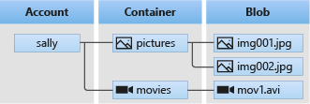

Fig 4.3 Relationship between resources

A number of solutions exist for migrating existing data to Blob storage:

* AzCopy is an easy-to-use command-line tool for Windows and Linux that copies data to and from Blob storage, across containers, or across storage accounts. For more information about AzCopy, see Transfer data with the AzCopy v10.
* The Azure Storage Data Movement library is a .NET library for moving data between Azure Storage services. The AzCopy utility is built with the Data Movement library. For more information, see the reference documentation for the Data Movement library.
* Azure Data Factory supports copying data to and from Blob storage by using the account key, a shared access signature, a service principal, or managed identities for Azure resources. For more information, see Copy data to or from Azure Blob storage by using Azure Data Factory.
* Blobfuse is a virtual file system driver for Azure Blob storage. You can use blobfuse to access your existing block blob data in your Storage account through the Linux file system. For more information, see How to mount Blob storage as a file system with blobfuse.
* Azure Data Box service is available to transfer on-premises data to Blob storage when large datasets or network constraints make uploading data over the wire unrealistic. Depending on your data size, you can request Azure Data Box Disk, Azure Data Box, or Azure Data Box Heavy devices from Microsoft. You can then copy your data to those devices and ship them back to Microsoft to be uploaded into Blob storage.
* The Azure Import/Export service provides a way to import or export large amounts of data to and from your storage account using the hard drives that you provide. For more information, see Use the Microsoft Azure Import/Export service to transfer data to Blob storage.

**4.2 Non-Technical Outcomes**

The Internship program helped me gain self-confidence in using the tool and also helped me enhance my communication skills. I was also a POC with the Infosys team and this helped me improve my leadership skills, The project coordinators were very helpful and guided me to understand the entire process. This made me learn easily and effectively.

**Personality Development:**

This Internship program helped me gain control over how to deal with the project and meet deadlines. It also helped me to use my skills effectively and further enhance them.

### **Communication Skills:**

This Internship program helped me to communicate with the project managers, project co-coordinators, and team members, which made me gain confidence in my communication skills.

### **Time Management:**

The Internship program helped me in maintaining time and completing tasks in a given time slot. Periodical interaction with the manager was undertaken so that any changes in the project would be carried out immediately. The assigned tasks were completed on time. This made me learn time management

**Chapter 5**

**Conclusion**

Throughout the 6 months of my internship, I have been learning consistently. My learnings include technical skills and interpersonal skills. I also learned many core concepts which helped me get a strong hold on the basics of many technical skills.

I also took part in the Future Leaders Innovation contest organized by the global Johnson Controls Team. It involved working with a diverse team spread across the globe with the mentorship of experienced Johnson Controls Engineers. I thoroughly enjoyed the contest and we presented to a panel of judges who were global Johnson Controls Leaders in the semi-finals. It involved developing solutions to the problem statements given to us by the management.

Some of the key aspects I observed are

* Result-driven and goal-focused approach to work.
* Enforcing discipline of performance management.
* Supportive employees with a wide range of training and further education opportunities, thereby, fueling their personal as well as professional growth.
* Similar treatment and similar benefits for all the employees as well as for interns.

During the internship, the benefit I achieved is to test out a job, employment setting, management style, and other aspects of the workplace.

**References**

[1]<https://www.johnsoncontrols.com/-/media/jci/careers/early-careers/ta2010003h_gi_brochure_draft_5_4.pdf?la=en&hash=4D22C283F7C4568085BFE1785A8A11D784B088C1#:~:text=As%20a%20member%20of%20the,your%20resume%20and%20professional%20network>.

[2]<https://www.informatica.com/in/products/cloud-integration.html>

[3]<https://apisero.com/informatica-intelligent-cloud-servicesiics-integration-with-snowflake/#:~:text=Informatica%20Intelligent%20Cloud%20Services%20(IICS)%20is%20a%20cloud%2Dbased,between%20cloud%20and%20local%20applications>.

[4]<https://www.trustradius.com/products/informatica-intelligent-cloud-integration-services/reviews?qs=pros-and-cons#product-details>

[5] https://docs.oracle.com/cd/E15586_01/fusionapps.1111/e15525/intro.htm

[6]https://docs.microsoft.com/en-us/azure/data-factory/concepts-pipelines-activities?tabs=data-factory

[7] https://docs.microsoft.com/en-us/azure/storage/blobs/storage-blobs-introduction